Technical Analysis
- Discipline that analyzes statistical trends from trading activity to evaluate and identify trading opportunities.
- Assumptions
  - The market discounts everything
  - Price movies in trends
  - History tends to repeat itself

Technical Indicators
- Technical indicators are mathematical calculations based on the price, volume, or open interest of a security or contract
  - Commonly used for short-term trades, however, can be utilized for longer term positions
- Display Types
  - Overlays: Displayed over the main price chart of asset
  - Oscillators/Indicators: Exist as separate charts below the main price chart
- Categories
- Trend Indicators: Measure direction/strength by comparing prices to set baseline
- Momentum Indicators: Compares current closing prices with previous closes, identifies speed of price movement
- Volatility Indicators: Measures rate of price movement in either direction
- Volume Indicators: Measures strength of trend based on volume traded

Candlestick Terminology

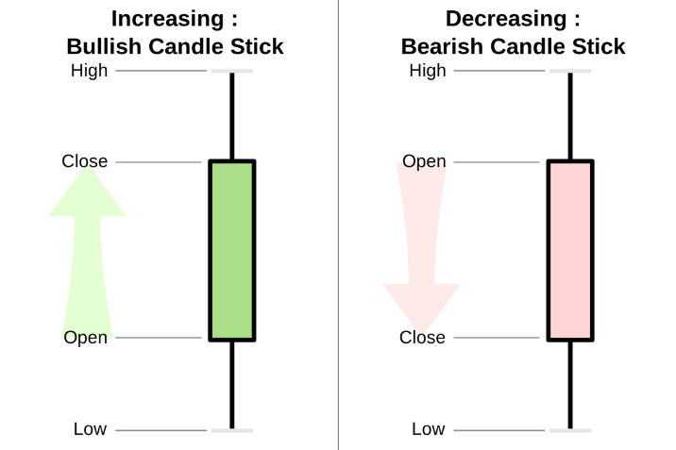
- Components of a candlestick
  - Upper Shadow
  - Real Body
  - Lower Shadow
- Bull/Bear Candlesticks
- Doji Candlestick
  - Little to no price action in real body
  - Could signify ending of a trend, or skepticism of uptrend/downtrend

Moving Averages
- Mathematical average calculated from a certain amount of past data points
- Two Types
  - Simple Moving Average (SMA)
  - Exponential Moving Average (EMA): Increased weight on more recent data
- Strategies
  - Crossover of Asset
  - Crossover of Two Moving Averages
    - Bullish Crossover
    - Bearish Crossover
- Disadvantages
  - Lagging Indicator
  - Shaky Success in Volatile Industries
  - “Market has no Memory” Ideology

